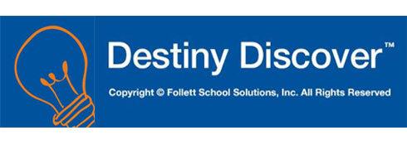

Dear Parents and Students,
The Jonesboro School District provides a library software program called Destiny. With this software, students may search their library catalog anywhere they have internet access. Individual students have a log-in name and password, enabling them to have their own account to create lists, do safe online research, save research files, and search many different databases .
Each student uses the following formula as their log-in information:
Username: graduating year, last name-first name (example: 23doe-jane)
Password: first initial, last initial, last four digits of district i.d. number, plus 2 zeros (example: jd629500)
Students may access Destiny by going to the following web address: library.jonesboroschools.net, then choosing their correct campus. Students may select the tab “Catalog” to search for books, OR log in to their account which launches Destiny Discover, a more student-friendly version, allowing the student to have many resources at their fingertips. If they are looking for materials on a certain topic, Destiny shows them books available in the library with the ability to reserve them or put them in their list, safe articles on the web, and One Search databases with the related information.
The Destiny Discover app may be put on any electronic device (smart phone, tablet, ipad, etc.) with web access. After loading the app, connect with the URL portal library.jonesboroschools.net. After connecting, log in with the individual username and password. The student will stay logged in every time they open the app unless they sign out manually.
With an increase in digital technology, such as electronic books (ebooks), students may also want to install the app for Follett Digital Reader on their tablet or smart phone. From the app store, install the app entitled “Destiny Discover”. The guest log-in is username: hurricane, password: flags OR the student may log in to their own account with their normal Destiny log-in. You should be able to access all of the ebooks we have available through our library program with this app, as well as download your own copy of the ebook. If you have any problem accessing this material, please see Ms. Phillips in the library.

